Final Product Definition and Scrum Team Plan
Submitted by
[Group 1 Yellow]
[Team Innovation]

Submitted on
[December 16, 2025]

Team Members
Adam Voss
Cory McCombs
Jacqueline Vo
Richard Sanchez

1. Final Product Name and Description

The product remains the Attendance Tracking System (ATS). It is a simple, multi-tiered web application designed to facilitate quick, verifiable, and error-proof class attendance logging.

Key Change: The core constraint has shifted. While still avoiding external APIs for core functionality , the system will now use a database for persistent data storage instead of a local XML file. The goal is to provide the professor with accurate, time-stamped records of student presence using a more maintainable data store.

2. Final Functionality Overview
The ATS focuses on core attendance submission and validation, plus new admin capabilities with functionality defined by the following "Must Have" and "Should Have" User Stories:
- Submission Input (User Story 1): Presents a simple UI (HTML/CSS) with an input box for the student's name, allowing input via typing or selecting a preset option. It uses client-side validation (JavaScript) against the class roster.
- Unambiguous Error Handling (User Story 2): Displays a distinct error state with visual cues beyond color upon failed client-side validation and disables the submit button.
- Backend Integrity (System Story 3): The Backend Submission Service (C#) strictly enforces the preset name list for all submissions. If client-side validation is bypassed with an invalid name, the service returns an HTTP 400 error, and the record is not stored.
- Confirmation Display (User Story 4): Upon successful submission, displays a confirmation screen with the message "ATTENDANCE LOGGED SUCCESSFULLY!", the student's name, and an ISO-8601 UTC timestamp.
- Accessibility & Keyboard Support (User Story 5): The system must implement ARIA properties and proper focus management to meet WCAG standards for keyboard and screen reader users.
- Log Another Submission (User Story 6): A button labeled "Log another" is present on the confirmation screen to quickly reset the UI for a new submission.
- Audit View (User Story 7 - Should Have): Implements a basic, read-only view that displays the last 25 successful/error submissions (name, timestamp, and status), ordered descending by timestamp.
- " System Story 9 (Roster Upload): As an administrator, I want an isolated page to upload a class list file, so that I can quickly update the roster for the system.
- " System Story 10 (Manual Roster Add): As an administrator, I want a dedicated "Add" button on the roster management page to manually input a single student name, so that I can make quick adjustments.
- " System Story 11 (Download Log): As an administrator, I want a "Download" button on the Submission Confirmation page, so that I can export the final, cumulative attendance log for my records.

3. Final Overview of Architecture
The Attendance Tracking System will utilize a multi-tiered architecture based on a simple separation of concerns.
- Platform: A standard web application accessible via a web browser.
- User Interface (UI): Built using HTML, CSS, and TypeScript with React (Web) for structure, presentation, accessibility, and component reuse.
- Business Logic/Validation: This layer handles data validation, timestamping, and the persistence process, and must be updated to manage SQL/database transactions instead of XML file parsing and writing. This update includes supporting the new Roster Upload, Manual Add, and Log Download functions, using the following technologies:
  - Client-Side: JavaScript/TypeScript for validation and basic suggestion heuristics (User Story 8).
  - Server-Side: C# .NET 8 (ASP.NET Core). This is the main server runtime, providing high throughput and integrated security.
  - Data Layer: The local XML file is replaced by a Database. Given the project scope and technology stack, a lightweight integrated database solution like SQLite or SQL Server LocalDB is recommended to maintain the "local" and "no external API" spirit while providing better data integrity and manageability than XML.
Core Constraint: Absence of external APIs.

4. Final Scrum Team Members

Name | Role | Hours/Week | Responsibility | Skillsets
Adam Voss | Developer | 5 | Development | C#
Cory McCombs | Product Owner/ Developer | 5 | Responsible for the backlog and value, development | Project Management, SQL
Jacqueline Vo | Scrum Master | 5 | Responsible for the process and removing impediments | C#, Python
Richard Sanchez | Developer | 5 | Development | C#, JavaScript, UI/UX

5. Final Virtual Daily Scrum Meetings

- Location: Discord
- Time chosen: 12:00 PM EST

6. Product Features To Be Delivered
The product backlog consists of all defined functional requirements, prioritizing the "Must Have/High Priority, Should Have/Medium Priority, Could Have/Low Priority" stories.
- ARCHITECTURAL CHANGE: Database Implementation: Migrate from XML data persistence to a database solution (e.g., SQLite/LocalDB) and refactor all read/write logic to use database queries.
- User Story 1-6: Implement core submission, error handling, confirmation, accessibility, and "Log another" features.
- System Story 3 (Backend Integrity): Update C# Backend Submission Service to validate against the new database roster.
- System Story 9 (Roster Upload): Implement the Admin Page with file upload for roster replacement.
- System Story 10 (Manual Roster Add): Implement the "Add" button for manual single-name roster insertion on the Admin Page.
- System Story 11 (Download Log): Implement the "Download" button on the Confirmation page to export the attendance log.
- User Story 7 (Audit View): Implement the last 25 submissions view (Should Have).
- User Story 8 (Fuzzy Match Recommendations): Implement front-end suggestion heuristics (Could Have).
- Security & Constraints: Implement required security posture.
7. Backlog for Each Sprint

This is a preliminary plan and is subject to change. The plan focuses on delivering the core "Must Have" features first.
The database migration and the admin page features require substantial refactoring and implementation and are prioritized accordingly.

Sprint 1 (2 Weeks)
- Focus: Core Architecture Migration and Submission Foundation.
  - Database Implementation: Set up the chosen database (e.g., SQLite) and refactor the backend C# logic to establish connection and CRUD operations for the Roster list and the Attendance log.
  - User Story 1 (Submission Input): Implement basic UI and client-side validation.
  - System Story 3 (Backend Integrity): Implement the C# backend validation service, now using the database for roster checks.
  - Unit Testing: Achieve >80% Unit Test coverage on the critical Server-Side Validation Logic (System Story 3).

Sprint 2 (2 Weeks)
- Focus: Admin Roster Management and Error Handling.
  - System Story 9 (Roster Upload): Implement the Admin Page with file upload functionality to update the roster database table.
  - System Story 10 (Manual Roster Add): Implement the manual "Add" button functionality on the Admin Page.
  - User Story 2 (Unambiguous Error Handling): Complete distinct error states implementation.
  - Security Posture: Implement strong admin authentication for the new Admin Page.

Sprint 3 (2 Weeks)
- Focus: Confirmation, Logging, and Export.
  - User Story 4 (Confirmation Display): Implement the Success Confirmation Screen with name and timestamp.
  - User Story 6 (Log Another Submission): Implement the "Log another" button.
  - System Story 11 (Download Log): Implement the "Download" button on the Confirmation page to export the full attendance log from the database.
  - User Story 7 (Audit View): Implement the basic, read-only view of the last 25 submissions (Should Have).

Sprint 4 (1 Week)
- Focus: Accessibility, Polish, and Quality Gates.
  - User Story 5 (Accessibility & Keyboard Support): Complete implementation of ARIA properties and focus management across all pages (Submission, Confirmation, Admin).
  - User Story 8 (Fuzzy Match Recommendations): Implement front-end suggestion heuristics (Could Have).
  - Maintainability/DoD Checks: Ensure all quantifiable quality gates are met >80% Unit Test coverage, >70% Integration coverage, etc.).
  - Functional UI Testing (Selenium): Automate end-to-end testing of all implemented features.
8. Screenshots of Visual Studio with Agile Tool

The team will be using Visual Studio Community as the primary development platform, utilizing C# .NET 8 for the backend logic and MSTest for Unit Testing.
- Screenshot 1: Shows the Test Explorer ready to run tests. The Test Explorer will be used to run MSTest to verify the C# backend logic and meet the >80% code coverage

- Screenshots of GitHub IDE Connection
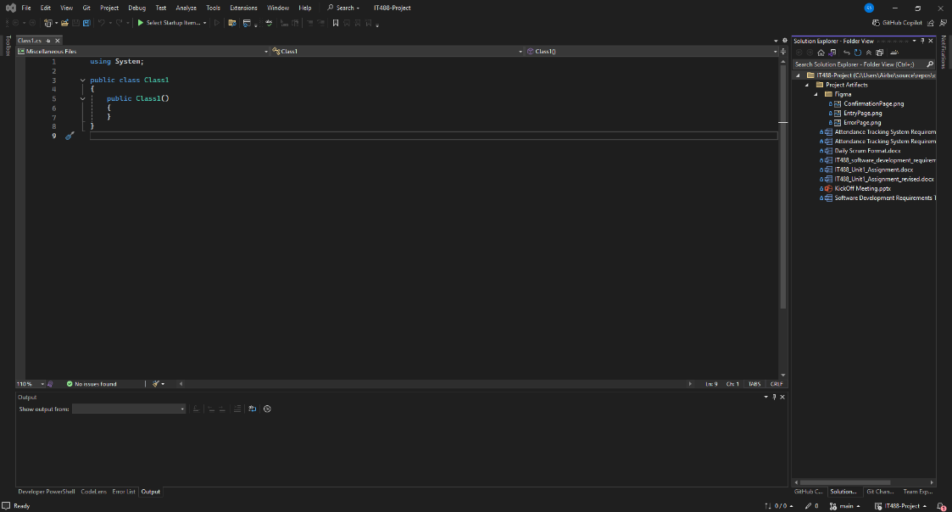

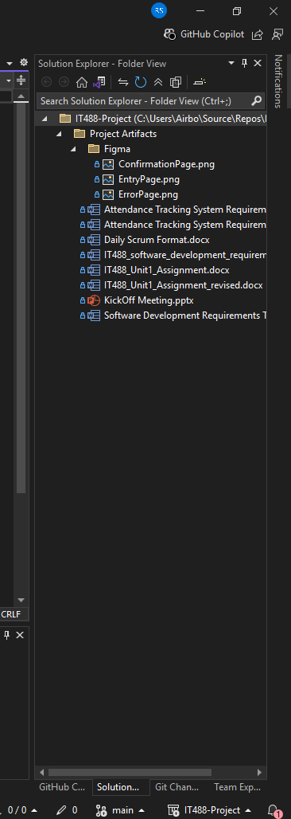
- requirement for the server-side validation.
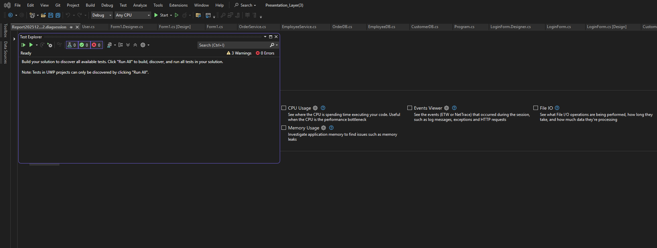
- Screenshot 2: Shows the Debug/Release configuration selector, indicating the environment for building and deploying the C# .NET 8 application.
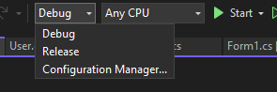
- Screenshot 3: Shows the Project Properties for source files, indicating the environment setup for the server-side code.
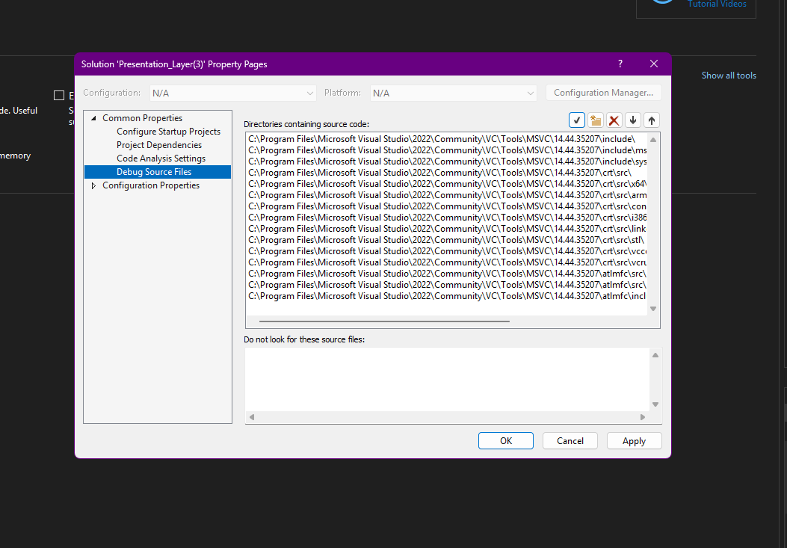

- Screenshot 4: Shows the Analysis Target with various performance analysis tools (CPU Usage, Memory Usage, etc.) that can be used to ensure the application meets the 200ms and 2s performance NFRs.
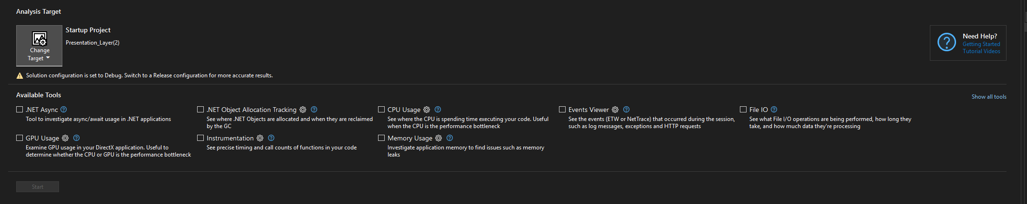
- Screenshot 5: Shows the current Jira Backlog

